Website Introduction (Structure & Components), WordPress Overview

Question 1
Draw a simple sitemap diagram for a food delivery website (like Zomato) showing the main pages.
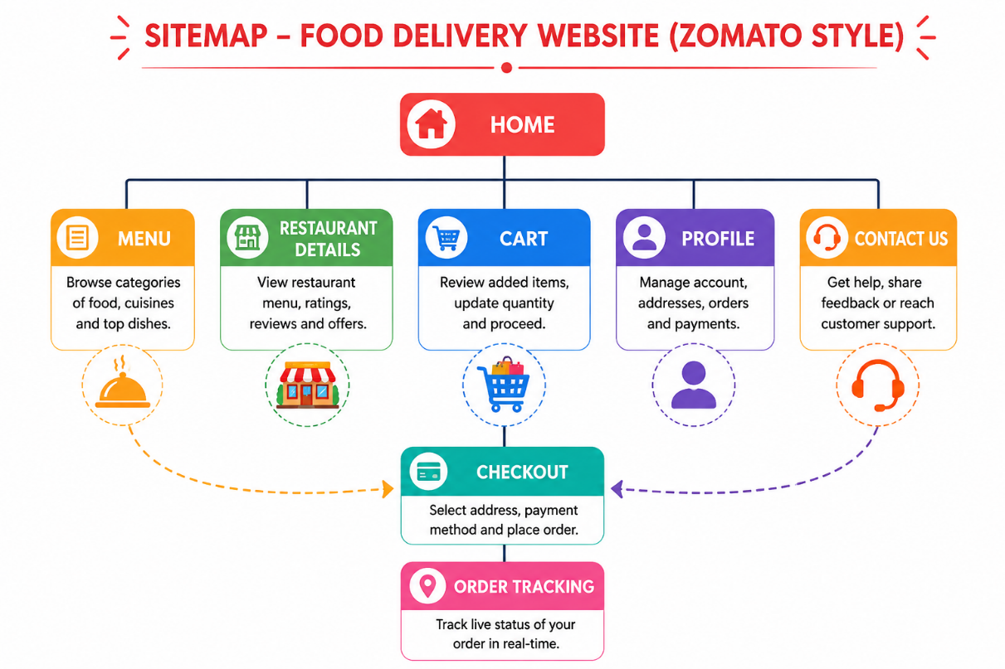

Question 2
List and briefly describe the purpose of five key components found on the homepage of an e-commerce website like Flipkart.
Homepage Component | Purpose
Navigation Bar | Helps users easily navigate to different categories like Electronics, Fashion, and Grocery.
Search Bar | Allows users to quickly search for products.
Banner/Slider | Displays special offers, festive sales, and promotional campaigns.
Product Grid | Shows featured, trending, and recommended products in a structured layout.
Footer | Contains links to Contact Us, About Us, Privacy Policy, Help Centre, and social media pages.

Question 3
Sign up for a free WordPress.com account, create a new site, and choose a theme that matches a music blog (Spotify-style). Take a screenshot of your theme selection page.
Answer:
This is a practical task that must be completed on your own WordPress account.
Steps:
- Visit https://wordpress.com.
- Sign up for a free account.
- Click Create Site.
- Choose a Music Blog theme (dark/minimal style).
- Take a screenshot of the Theme Selection page.
- Insert the screenshot into your assignment.
Screenshot Required: Theme Selection Page
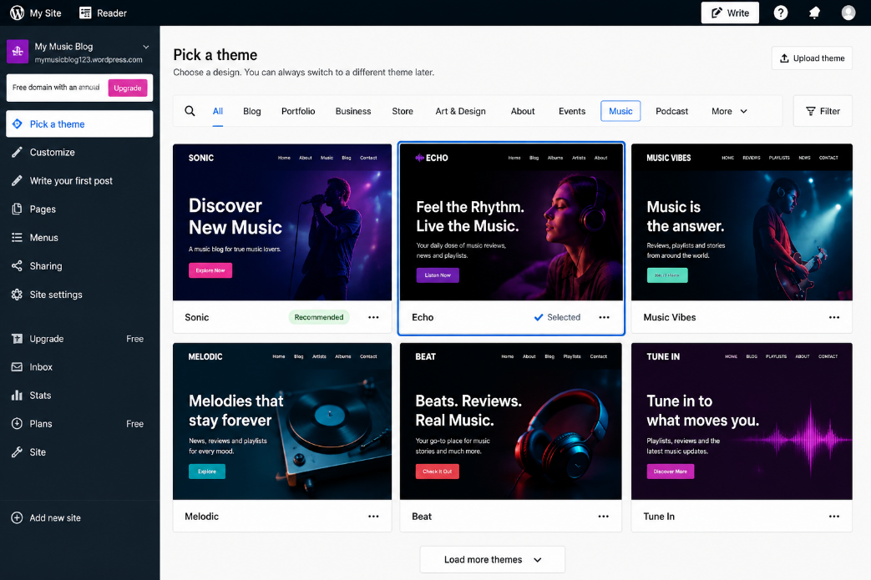

Question 4
Add and publish a new page titled "Upcoming Events" on your WordPress site and set it to appear in the main menu.
Answer:
This is also a practical task.
Steps:
- Log in to your WordPress Dashboard.
- Go to Pages → Add New.
- Enter the title Upcoming Events.
- Add a short description (optional).
- Click Publish.
- Go to Appearance → Editor (or Menus).
- Add Upcoming Events to the Main Navigation Menu.
- Save the changes.
Screenshot Required: Published "Upcoming Events" page with the navigation menu.
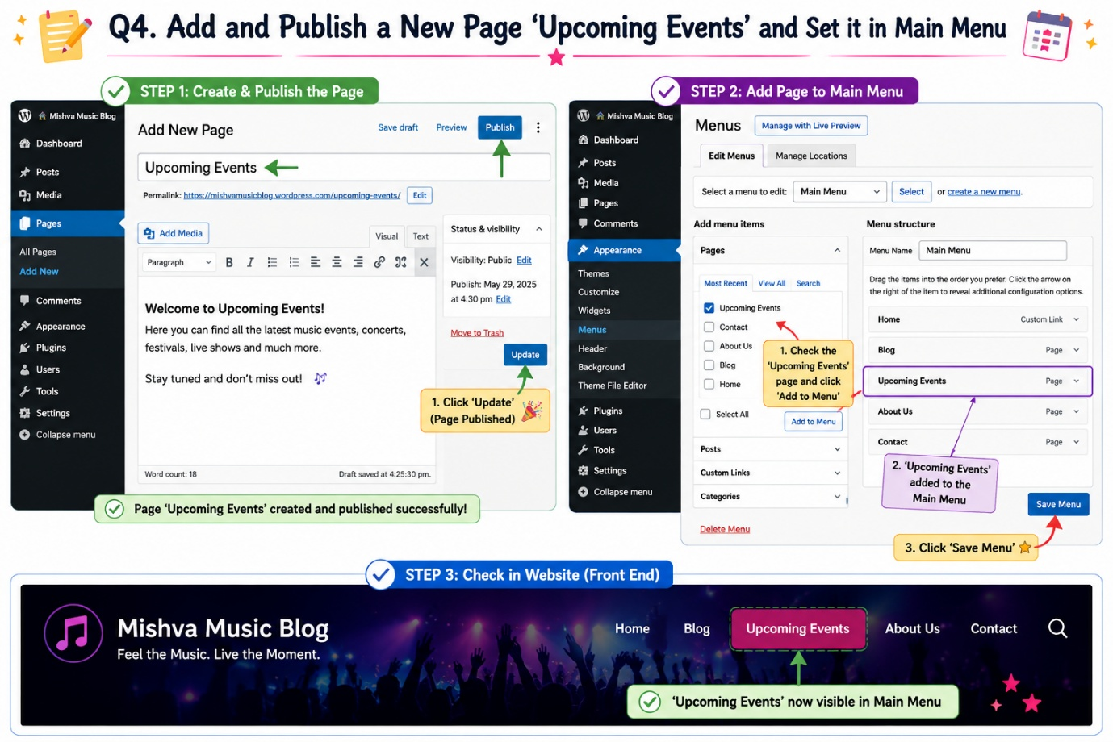

Question 5
Customize the header image and site title of your WordPress site to reflect a movie review blog (BookMyShow-style), and preview the changes before publishing.
Answer:
This is a practical task.
Steps:
- Open the WordPress Dashboard.
- Go to Appearance → Editor → Site Identity (or Customize → Site Identity, depending on the theme).
- Change the Site Title to:
  - Movie Review Hub
- Upload a movie-themed Header Image (film reels, cinema, popcorn, etc.).
- Click Preview to view the changes.
- If satisfied, click Publish.
Screenshot Required: Preview of the updated header image and site title before publishing.
